
Classroom Saving Graces

1st – Seating Set-Up: Along with your seating chart, also consider:
- Buddy-Pairs as a natural part of the set-up, and Double-Buddies as a natural set-up for Cooperative Learning
- Variety of work area options, available for all students:
  - Regular desk with privacy folder screens as a signal of “Student Working,” if needed or wanted
  - Quiet table/desk area(s)
  - “Stand-up” desk – raised desk for students who need the option to standing while working to alleviate restlessness.
  - Different “chair options” around the room where the children can work – regular desk chair, library corner floor cushions, story time armchair and rug area, etc.

2nd – “Chunk & Chew” and Move!
- The 10-2 Rule: for every 10 minutes of instructions, provide 2 minutes for the students to process or interact with the information.
- Incorporate embedded movement to the process:
  - Total Class Response – such as:
    - “Thumbs Up / Thumbs Down / Thumbs Sideways”
    - “4-Corners”
See the Resource Links at the End!
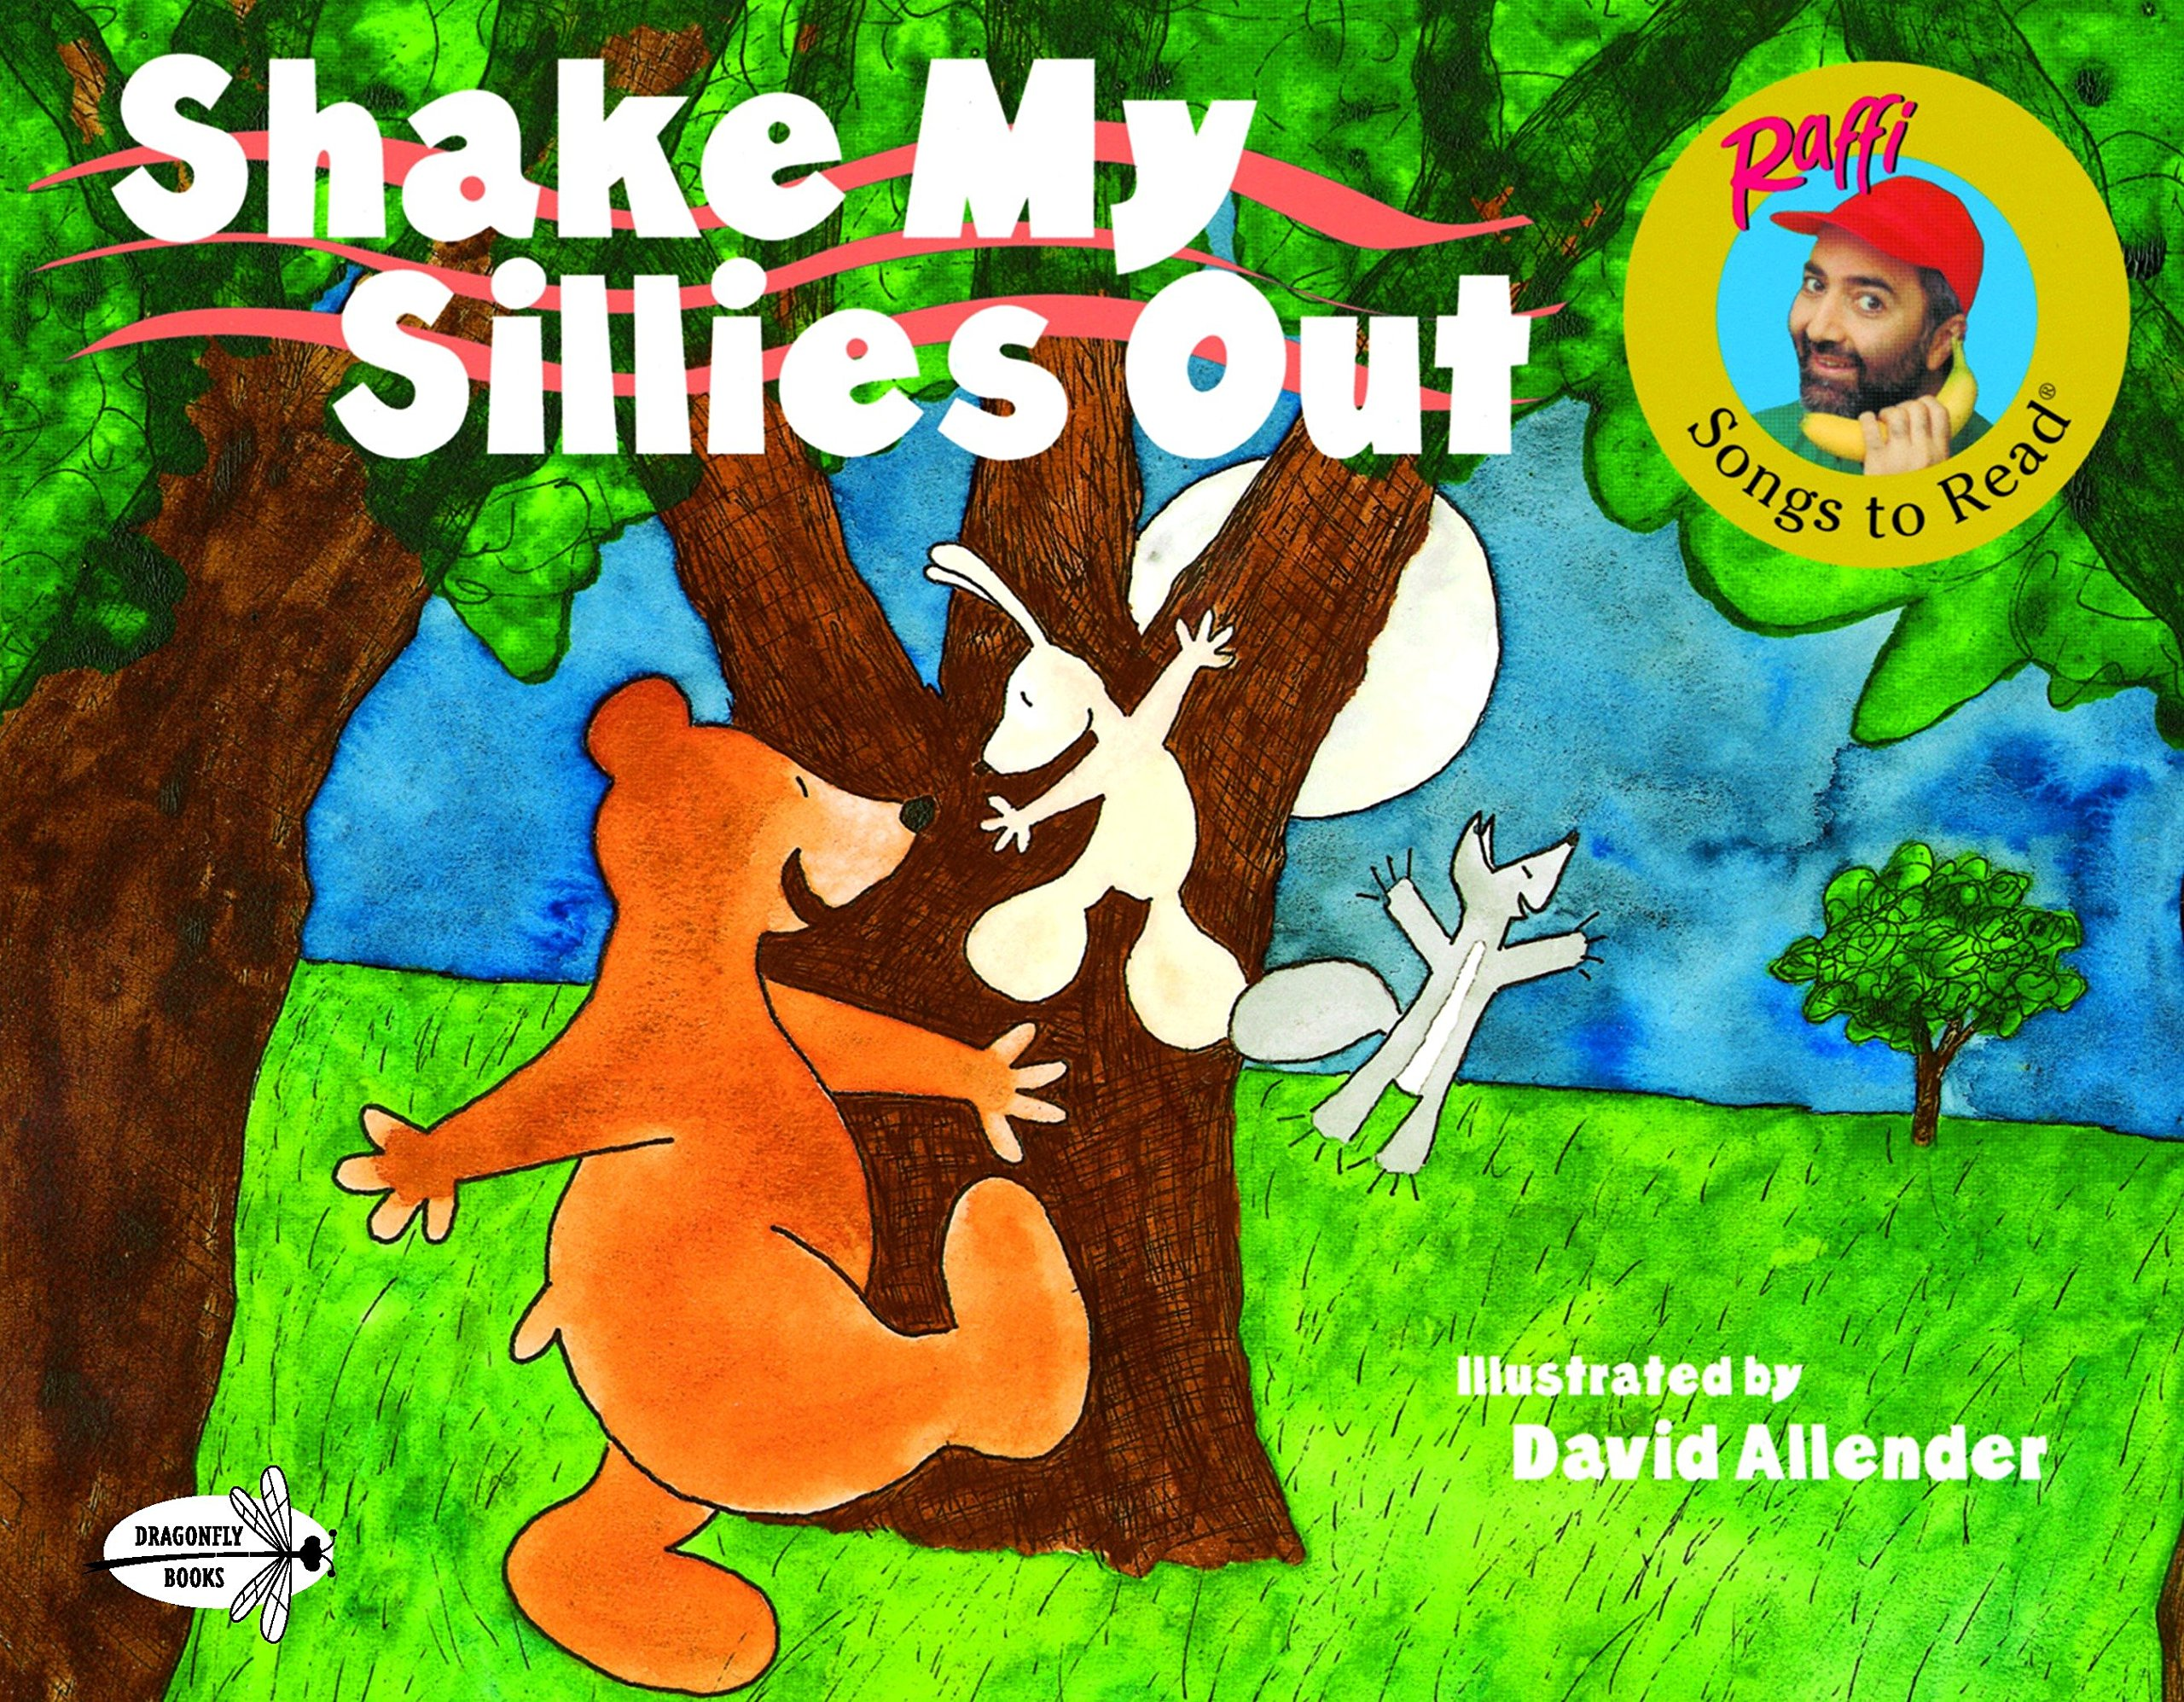
    - “Parking Lot”
  - Monitor restlessness and students tuning out:
    - “Quick Write”
    - “Think-Pair-Share”
    - “3-2-1”
  - Sometimes you’ll just have to Shake My Sillies Out!

3rd – Name Sticks with a Twist – Write each student’s name on a popsicle stick or tongue depressor, and then:

- Give the question and think time before pulling a name stick.
- Have blank sticks = Call on anyone, even a “repeat customer!” [… continued …]
- At times, addition options could be:
  - Phone a Friend (by student pulling another stick)
  - Ask the Audience (The class gives Thumbs Up/Down after the student who was called on gives his/her potential answer.)


4th – “I’m Done” Checklist and Choices
- Create a “I’m Done” checklist:

Am I Really Done?
1) I put my name and date on it.
2) It is neat and complete.
3) I double-checked everything, using the connected checklist and/or rubric.)
4) I went above and beyond – showing an
extra s-t-r-e-t-c-h?
5) I can proudly say, “This is my best effort!”

- Create a leveled Choice Chart when students are truly done, and you want to keep them active and engaged with learning while the class is finishing work:
  - GREEN choices: Options for all, perhaps could include:
    - Reading in the Library Corner (and they log this in their Reading portfolio – Read to Self, Read with Buddy).
    - Author Cycle choices
  - YELLOW choices: These could be earned options, such as:
    - Going to the School Library with a pass
    - Revisiting a previous Center activity (teacher selected options)
    - Puzzles or Math activity games

5th – Class Names Slips – Having a narrow stack of slips that
has your class list of students will come in handy in so many ways.

- Quick check-off for students turning in office notes.
- Monitoring engagement – hands-up, “pats on back,” “repeat & add more.”
- … Oh, and you can think of so much more! (^_^)

Some Resources
The Titles are hyperlinked if you pulled this up as a Word-Doc – so click and go!

10-2 Rule – https://leadinglearningmatters.wordpress.com/tag/10-2-rule/

6 Strategies for Effective Learning – http://www.learningscientists.org/downloadable-materials/

Edutopia – How to Keep Kids Engaged in Class – https://www.edutopia.org/classroom-student-participation-tips

UC Berkley: Active Learning Strategies – https://teaching.berkeley.edu/active-learning-strategies

40 Active Learning Strategies for Active Students – http://teaching.monster.com/benefits/articles/8414-40-active-learning-strategies-for-active-students-

101 Interactive Techniques (It’s actually 273 ideas!) – https://www.usf.edu/atle/documents/handout-interactive-techniques.pdf

Instructional Strategies to Increase Student Engagement – http://www.esc5.k12.in.us/index.php/inside-wvec/documents-and-forms/student-engagement/835-instructionalstrategiestoincreasestudentengagement/file

Active Learning and Teaching Methods – http://www.nicurriculum.org.uk/docs/key_stage_3/altm-ks3.pdf

Top 10 Evidence Based Teaching Strategies – http://www.evidencebasedteaching.org.au/evidence-based-teaching-strategies/

14 Classroom Activities That Increase Student Engagement – https://www.readinghorizons.com/blog/14-classroom-activities-that-increase-student-engagement

